**Use Case document for Cisco Catalog Update:**

ph2842 is the guy who we have to contact if we have not received files from Cisco team on 1st and 3rd Monday of each month.

1. From Emails download Catalog file and Service files for all 11 regions.

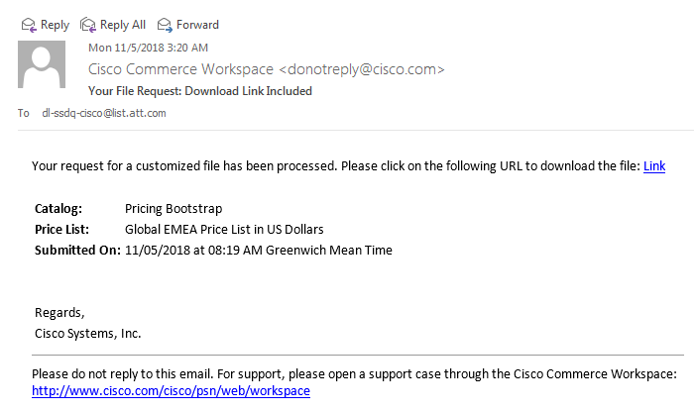

Click on Hyperlink Link and then enter username and password DataCommerce / TsProd35 to download file.

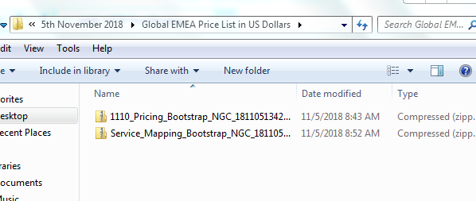

Save files like above.

1. We have to upload only 2 regions in 1 day.
2. We have to start upload after 8 AM ET and before 2 PM ET.
3. In database check if Process Status is C or I. We have to initiate load only if process status is C.

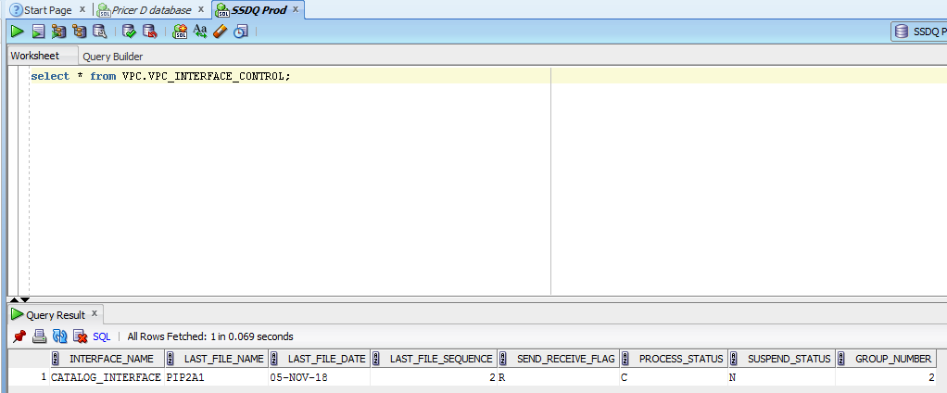

1. Copy all the files in temporary folder (ex: /tmp/ssdq) in zlpv7357.vci.att.com using winscp.

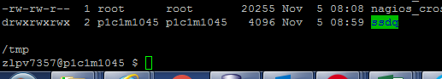

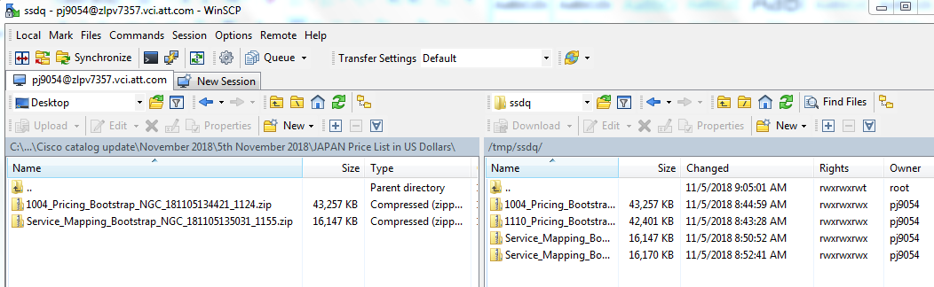

Same will be reflected on unix server as well.

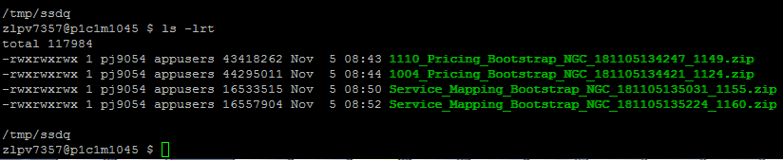

1. We have to check cronjob file and change the timing of vpcload.sh to a future timing before change files to .txt format before copying the files in the specified folders

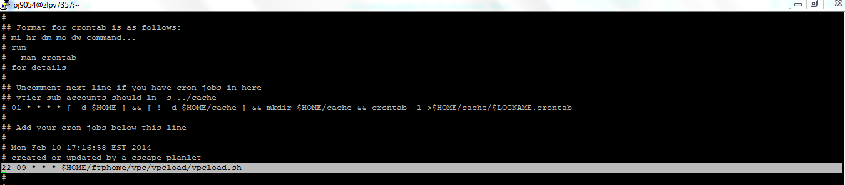

1. Change permissions of all files to 777.
2. Unzip all the files and then remove all .zip files and keep only .txt files.

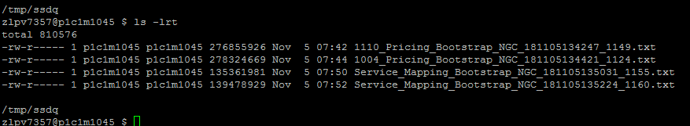

1. Copy .txt pricing files in /opt/app/p1c1m1045/ftphome/vpc/vpcload/cisco_pricing folder

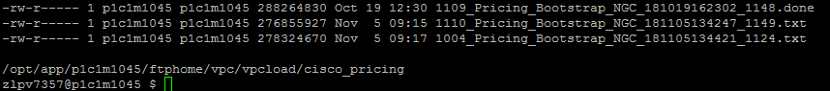

and .txt service files in /opt/app/p1c1m1045/ftphome/vpc/vpcload/cisco_service folder.

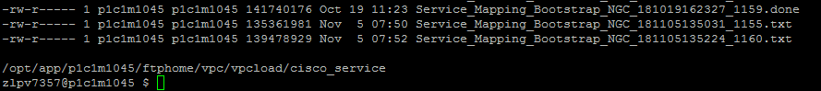

1. After files are copied then at whatever time cronjob is set process will start.
2. As soon as job starts we can see logs in /opt/app/p1c1m1045/ftphome/vpc/vpcload/cisco_pricing folder using tail –f ciscovpcload.log command.

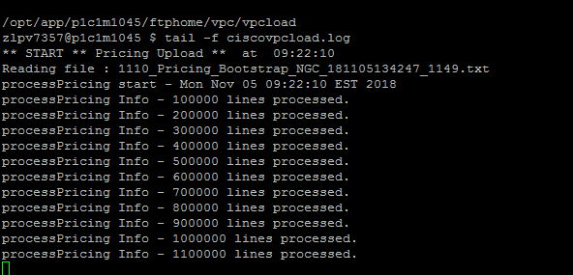

1. As soon as load is started process status will change to “I”

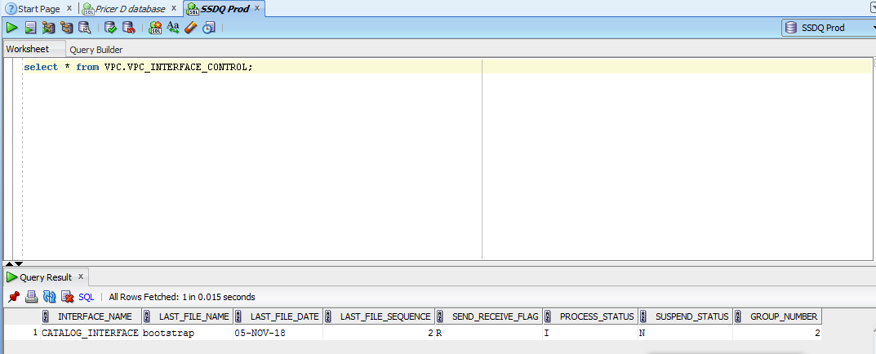

1. After load is done we will get a completion email and then we can again check in database Process is “C” and all the files should change from .txt to .done format.

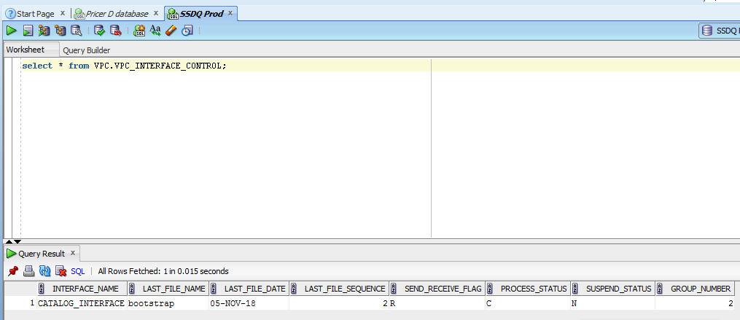

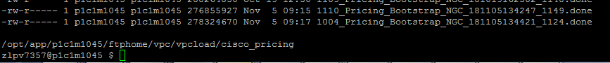



1. Repeat the same same process till all 13 files are not done.
2. Send completion email to everyone stating cisco catalog upload is done.